Expense Reimbursement System

# Executive Summary

The Expense Reimbursement System (ERS) will manage the process of reimbursing employees for expenses incurred while on company time. All employees in the company can login and submit requests for reimbursement and view their past tickets and pending requests. Finance managers can log in and view all reimbursement requests and past history for all employees in the company. Finance managers are authorized to approve and deny requests for expense reimbursement.

**State-chart Diagram (Reimbursement Statuses)**

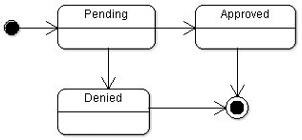

**Reimbursement Types**

Employees must select the type of reimbursement as: LODGING, TRAVEL, FOOD, or OTHER.

**Logical Model**

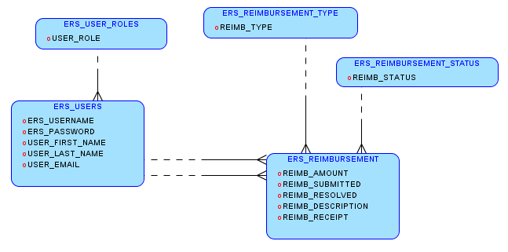

**Physical Model**

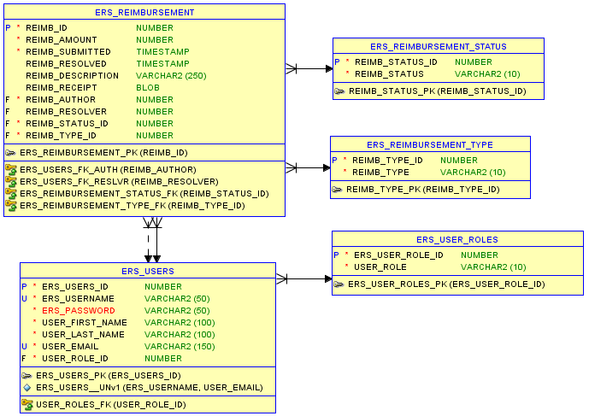

**Use Case Diagram**

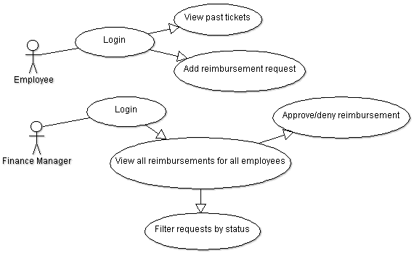

**Activity Diagram**

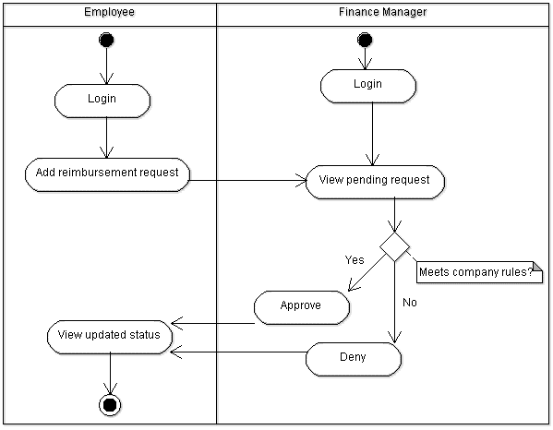

# Technical Requirements

The back-end system shall use pg to connect to an Postgres database. The application shall deploy onto Node.js server. The middle tier shall use Express technology for dynamic Web application development. The front-end view can use JavaScript or optionally React to make an application that uses AJAX to call server-side components. Passwords shall be hashed (optional) in Node.js and securely stored in the database.